
Project Name: Key Bank Plus and the Buckeye Plaza Financial Education Center
A program that provides financial services and education to low and moderate income individuals in order to facilitate formal banking practices, savings and wealth.

Federal Reserve District(s): Cleveland

Program Location: Cleveland, Ohio Program Geography: Urban

Program Start Year: 2004 Program End Year: Ongoing

Lessons Learned Highlight:
- Offering financial education programs inside a bank branch can help families save and build assets.
- Even a for-profit banking institution has a self-interest in committing financial services to low and moderate income communities
- The partnership of a non-profit provider of financial education programs and a for-profit banking institution can create a cost-effective outcome for both institutions and the community at large.
- A welcoming environment reflecting community demographics and culture can foster an approachable banking experience and ease intimidation for new bankers.
- A biometric identification system can serve to provide security for both banking institutions and the non-traditional customers who use their cash-checking services.

Project Description:

Key Bank, a community development bank, maintains ongoing initiatives to attract and provide services to low-to-moderate income (LMI) communities. In the 13 states where it operates, 25% of Key Bank branches are located in LMI communities. Among residents there, Key Bank found that nearly 40% did not have checking accounts or use traditional methods of banking. WECO Fund, Inc., a non-profit provider of financial education and services, seeks to promote financial stability to low and moderate income households. The partnership of these two organizations offers cohesive outreach to the low and moderate income community of Cleveland, Ohio. This is done by way of the Key Bank Plus program at the Buckeye Plaza Financial Education Center that provides financial services and education to low and moderate income individuals in order to facilitate formal banking practices.

The 6,000 square foot comprehensive center is divided into an identified Key Bank branch and a financial education center consisting of a training room seating 50, a computer lab seating 10, a conference room and individual offices. The center was renovated before its opening to reflect community demographics and deviate from the typical “corporate” look of a bank. This reform specifically aimed to create an approachable atmosphere for first-time bankers and to endorse a sense of community, both important objectives of the program.

At the center, check-cashing services are provided to customers at a lower fee than other check-cashing institutions. By offering a service already in practice at a competitive rate, the center was able to draw many potential customers in the community to an institution with the potential to infiltrate them into the mainstream financial system. In order to provide security for individuals who wish to cash their checks at Key Bank but are not traditional customers, a biometric identification system is used. Rather than ink-stamping their fingerprints on each occasion that a service is provided, cash-checkers use a machine to scan their thumbprint during their first visit to the center. Their information is saved in the system making the identification process efficient for return users.

Check-cashers are encouraged to attend both group and individual financial education courses offered by WECO. These courses cover a variety of topics and are conveniently located in the center. Open to the public, the group course topics include budgeting, credit card management, record keeping, home buying and avoiding predatory lenders. One-on-one sessions work with individuals on enhancing savings, debt reduction, and asset development skills.

Although check-cashers are not required to engage in any other services, Key Bank also offers other services to low income clients through a set of products called Key Basic Solutions. These services include a free checking account, a savings account with no minimum balance for 18 months and a flexible line of credit. These products are the potential next step to integrate individuals involved in the Key Bank Plus program into the mainstream financial system.

Program Results:
Since 2004, the center has provided financial education to over 2,200 individuals in the local community through their group educational classes. Since the programs inception, 181 checking accounts have been opened, and since 2005, 39 savings accounts have been opened. During individual counseling, new clients are asked to pledge a certain amount to be saved. Since the start of the program, $10,733.67 has been pledged to be saved. The total amount of disputed debt since 2004 for program members is $150,617.00. In addition, over 4,200 new individuals have enrolled in Key Bank Plus check-cashing services. The project has been profitable for Key Bank through the collection of check-cashing fees. Profits have reached $105,757 as of 10/30/06, while losses remained manageable at $3,200. The implemented biometric identification system has proven to provide security for both the bank and its customers, resulting in limited loss.

Lessons Learned:
- Offering financial education programs inside a bank branch can help families save and build assets. Individuals who have problems saving need to be offered the combination of financial tools and education in a convenient setting. The Buckeye Plaza Financial Education Center operating in the same building as a Key Bank branch offers this convenience.
- Even a for-profit banking institution has a self-interest in committing financial services to low and moderate income communities. Key Bank seeks to serve the low-to-moderate income community while still making a profit. By offering check-cashing services to non-customers at a competitive rate, Key Bank is able to attract customers and profit from their check-cashing fees. The possibility that these individuals may become potential Key Bank customers in the future is a further incentive for Key Bank.
- The partnership of a non-profit provider of financial education programs and a for-profit banking institution can create a cost-effective outcome for both institutions and the community. WECO Fund, Inc. and Key Bank were each individually looking for ways to address the local low-to-moderate income household barriers to saving and lack of both formal banking practices and financial education. Without their partnership, the Buckeye Plaza Financial Education Center could not be turned into the comprehensive center, offering the multitude of services it does today.
- A welcoming environment reflecting community demographics and culture can foster an approachable banking experience and ease intimidation for new bankers. Many individuals outside of the formal banking system are hesitant to bring their business to a bank. They are cautious of fees, minimum balances, fear giving up control of their money, and often want to keep their finances private. By developing an approachable dynamic and accessible location for the center, individuals are more trusting of the Buckeye Plaza Financial Education Center, and are thus willing to utilize the financial services available there (See picture below).
- A biometric identification system can serve to provide security for both banking institutions and the non-traditional customers who use their cash-checking services. Banks rarely offer financial services to non-customers. In order to offer check-cashing services to non-customers, Key Bank needed a way to identify the users of this its services. Using a biometric scanning system allowed Key Bank to get the information it needed to provide financial services to non-customers, while providing these individuals with a sense of security that no one else could get access to their money. While Key Bank officials initially expressed skepticism regarding the willingness of the unbanked to submit to a fingerprint scan in order to receive services, customers generally report the biometric identification system to be a positive feature that offers them more security.
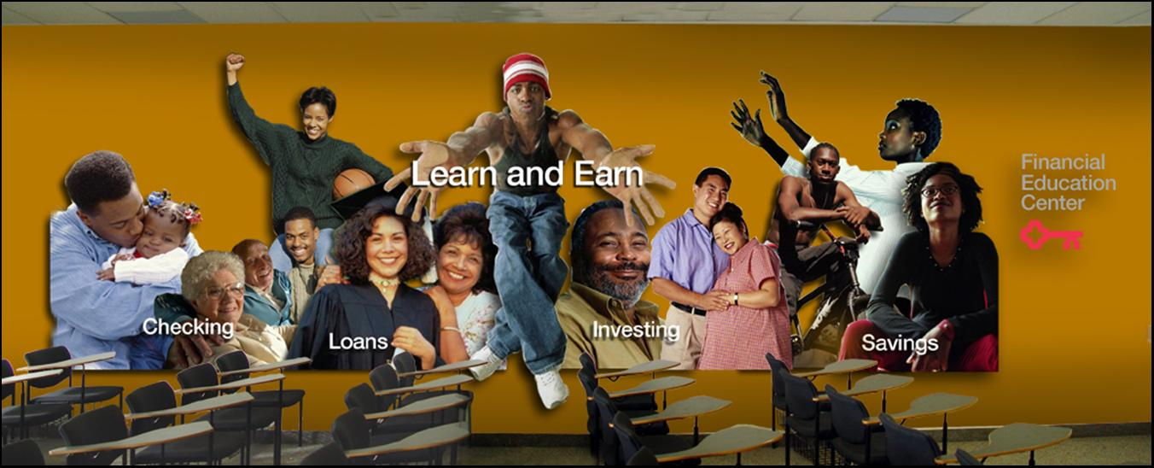

Program Lead Organizations:
Key Bank, WECO Fund, Inc.

Program Partners:
The center partners with local employees and religious centers to advertise and promote its services.

Contact Name, Address, Phone Number and E-mail:
George Barany
Director of Financial Education
Consumer Federation of America
(216) 375-3255

Bruce Murphy
President, Key Community Development Banking
(216) 689-8337

Buckeye Plaza Financial Education Center
11461 Buckeye Road
Cleveland, OH 44104
(216) 370-5630

Category: Financial and General Education, Asset Building, and Training

Key Words: Banking, savings, wealth, asset development, check-cashing, financial education.

Date Prepared: 10/26/06

This document was obtained from the Federal Reserve Bank of Chicago Website at [insert URL]. The Federal Reserve System attempts to verify the information presented, but cannot guarantee the accuracy of any information nor does the inclusion of any particular project or program represent an endorsement by the Federal Reserve System. The views expressed herein do not necessarily represent the views of the Federal Reserve System. For additional terms and conditions that apply the use of this and other information obtained from the Federal Reserve Bank of Chicago Website please review the Privacy Policy and Legal Disclaimer found at the Website address listed above.

